The Incredible Machine

By FLL Team Project Bucephalus

# Task

Build a network of robots that pass LEGO balls between each other without human assistance. Watch a sample here: https://www.youtube.com/watch?v=_v5IPvth_gE

Duration:

A simple design will take a single 2-hour class. A more complex design will stretch over 3-4 classes.

Objectives:

* Learn how to work on individual tasks within an overall group project.
* Discover Simple Machines.

Equipment:

This activity requires 4-20 MINDSTORMS® kits (EV3, NXT, Education or Retail) and a supply of LEGO® balls.

Students:

1-2 students build robot, limited to the contents of the set from which they are working.

Student Instruction Overview:

* Build a network of robots that take LEGO balls and pass them between each other without human assistance.
* Robots should “connect” to various framework pieces that have already been designed. These pieces will be locked into place and can be modified if needed.
* Each robot should use at least **one** over-complicated method to move the LEGO balls. **Gravity doesn’t count!**
* The main goal is to have a steady stream of balls moving through the chain. It doesn’t have to be a complete chain – there can be a beginning and an end.

Setup:

* Begin by placing MINDSTORMS bricks within a set formation decided by the class. A simple circle or square is fine (although a little boring).
* **Advanced Only:** Be creative! Go up and down tables, or try and bridge open distances.
* 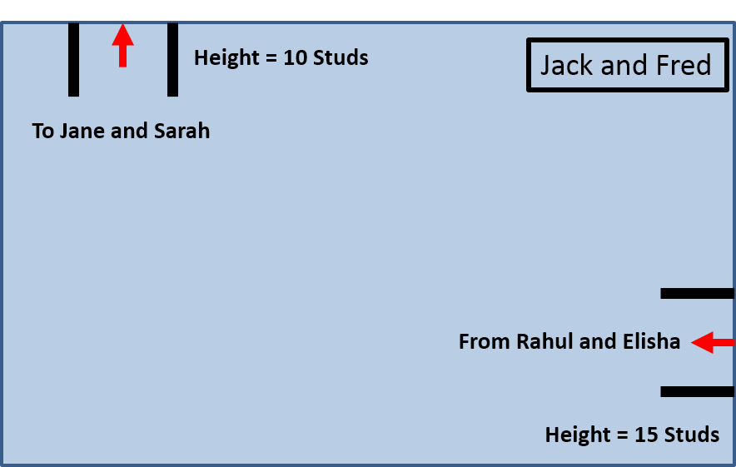MINDSTORMS Bricks should be spaced between frameworks. Use A4 sheets of paper to mark locations.
* Use the formation to define the “sender” and “receiver” locations for each robot.
* Each team is to discuss the angle and direction of the links sending and receiving the LEGO Ball between robots.
* Note the team(s) on either side of you!

Rules:

* You don’t have to physically connect the different robots to each other or the framework.
* Robots cannot move from their starting position in the network.
* No robot can hold a ball motionless for more than 5 seconds.
* Balls cannot touch each other while in the machine.
* No human intervention is allowed once the ball is in motion.

Tips:

* Balls roll downhill – but at least one robot in the machine will need to “lift” the ball.
* How many balls can your robot “juggle” before passing them on?
* How do you prevent ball collisions?
* Build a stable base to prevent your robot from moving.
* Test sensors to find the best ball detectors.
* 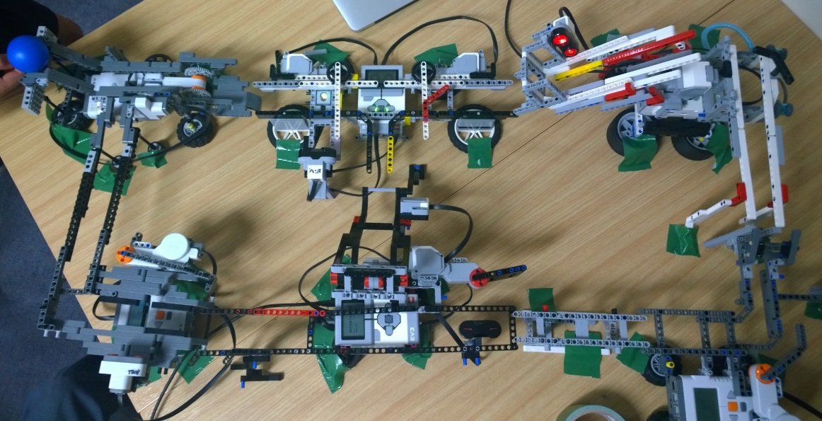Keep talking to your linking robot owners to make sure your robots can connect!

Feeling Advanced?

* Build a machine to keep multiple balls active at once.
* Earn bonus points by raising the ball as high as possible.
* Build Multiple paths through your machine.
* Build a “shortcut” to another machine with multiple paths!
* Design a complex program to eliminate error.
* Make creative use of lights, sounds, and display to make your machine interesting to watch.